SOP of Mapping on Web

Web data collection
- Log in to 192.168.11.3 Username: UBTNB Password: ILOVEUBT
- Enter the mapping interface
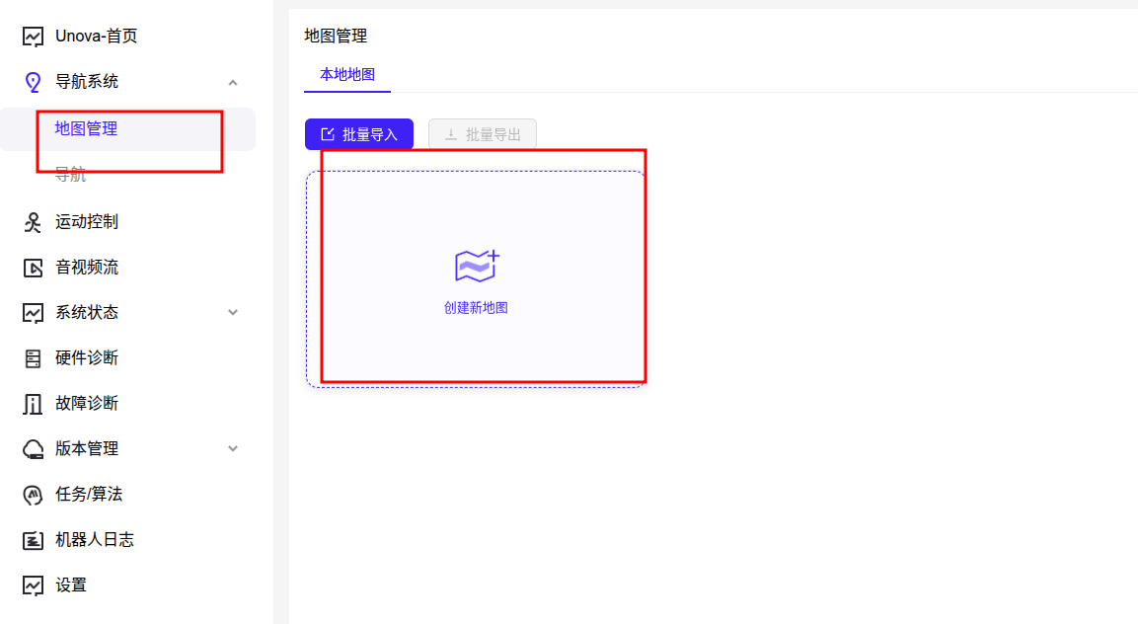
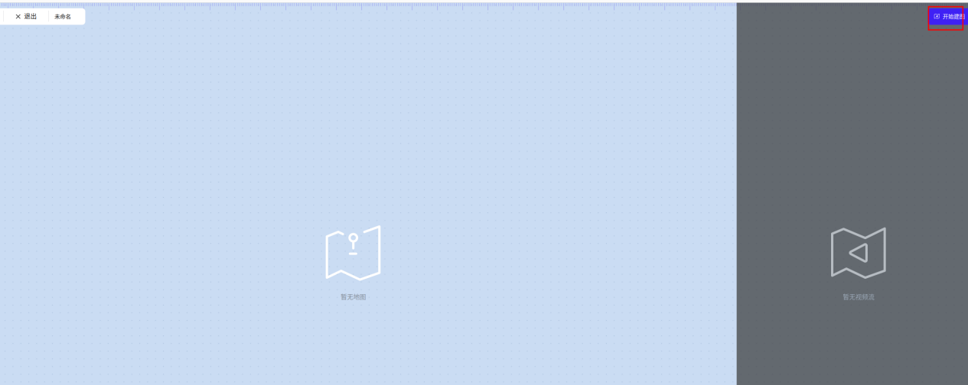
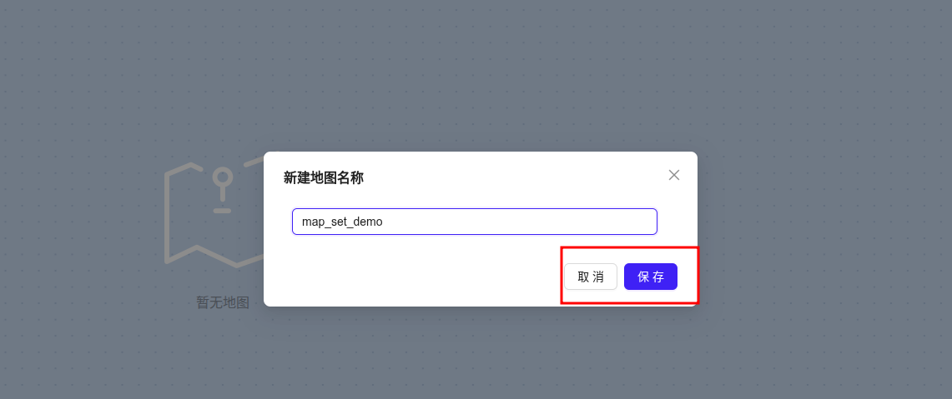
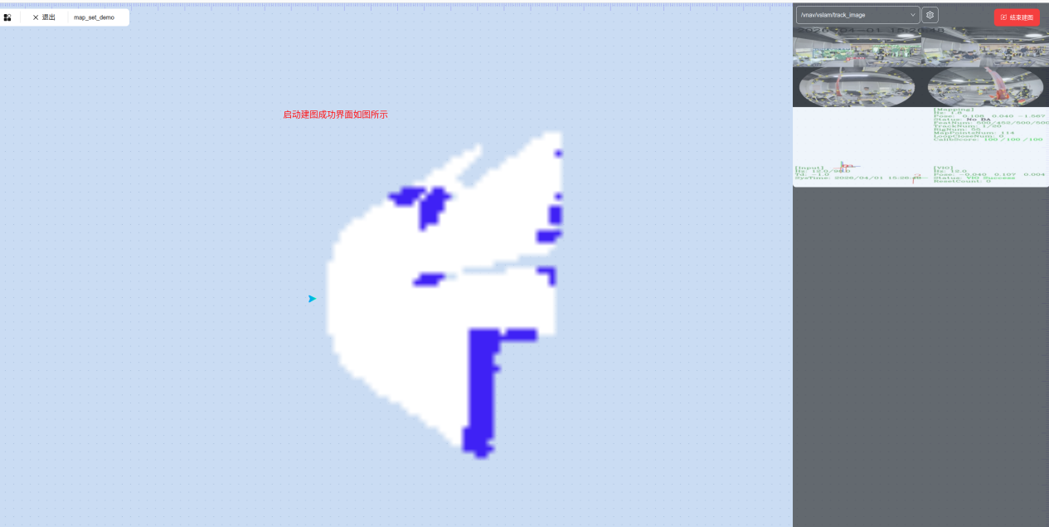
- Walk around the venue once and observe the visualization page
- Click to end mapping
- Click Map Management
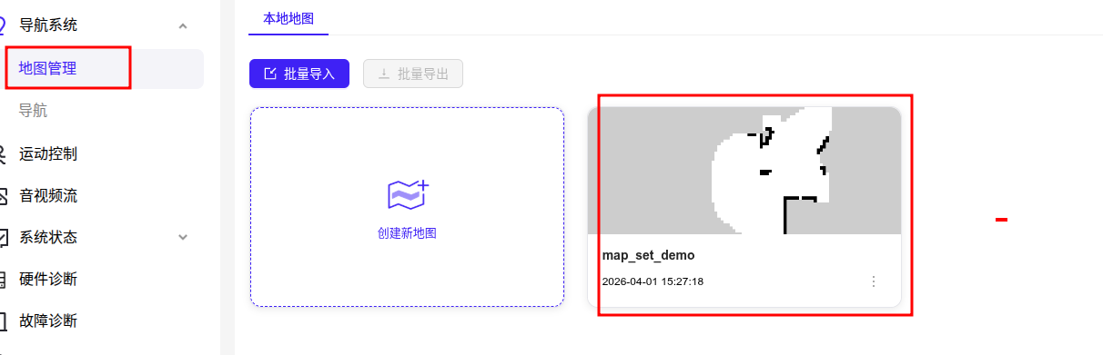
- Mark a point, record the current position, enter the point name, save it, and repeat the operation
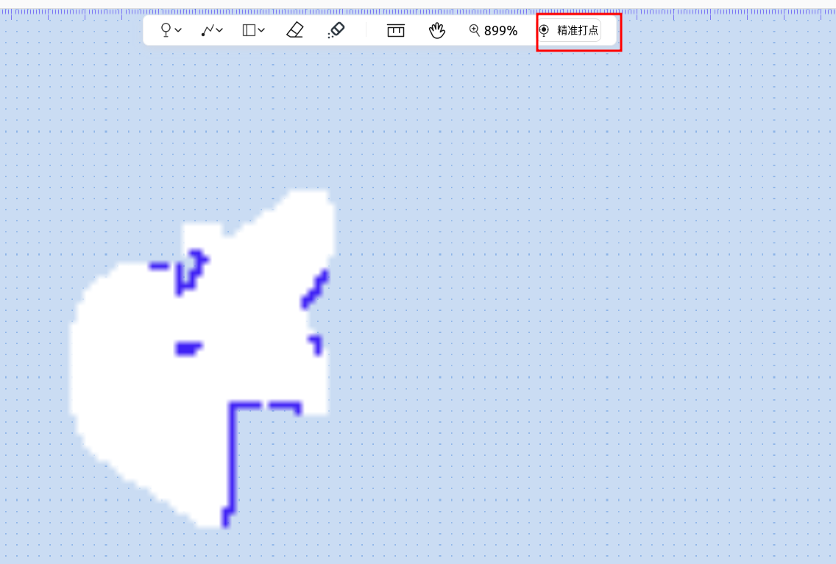
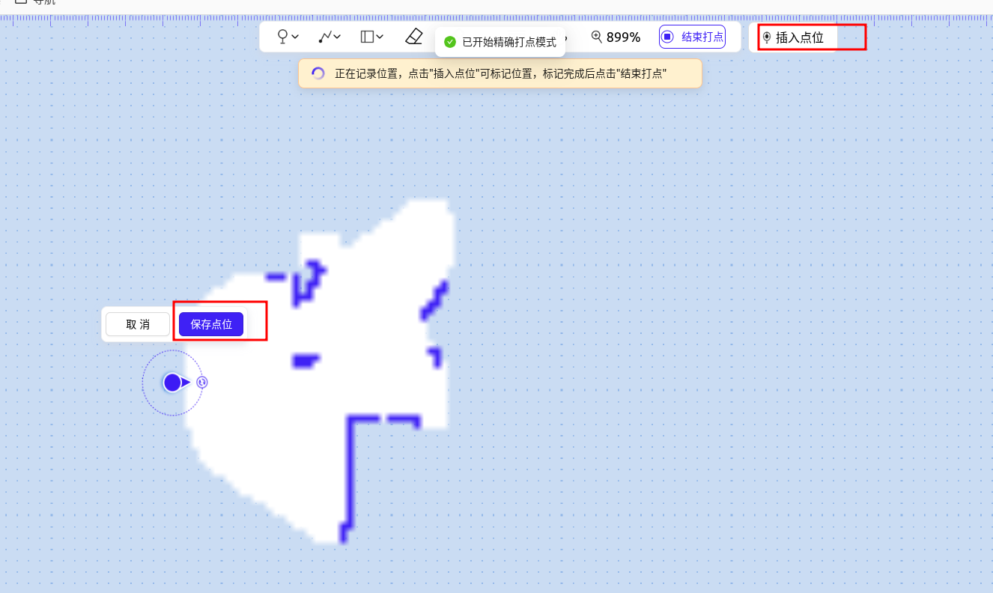
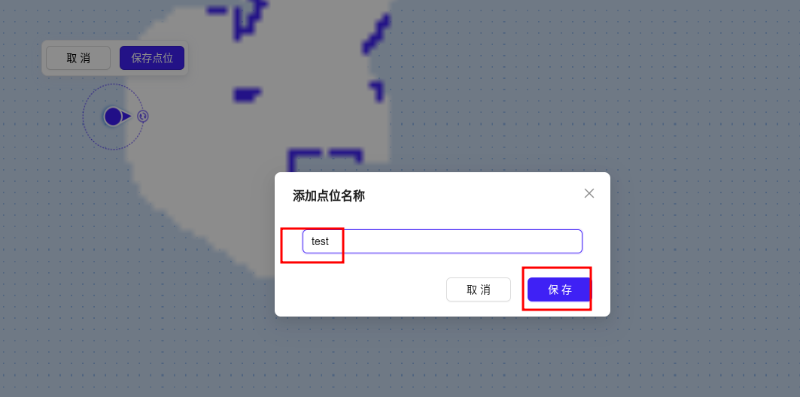
- Click the top right corner to complete and save
- Finally save, enter 192.168.11.3:/etc/walker/map/Map Name/umap, and modify the umap.json file
